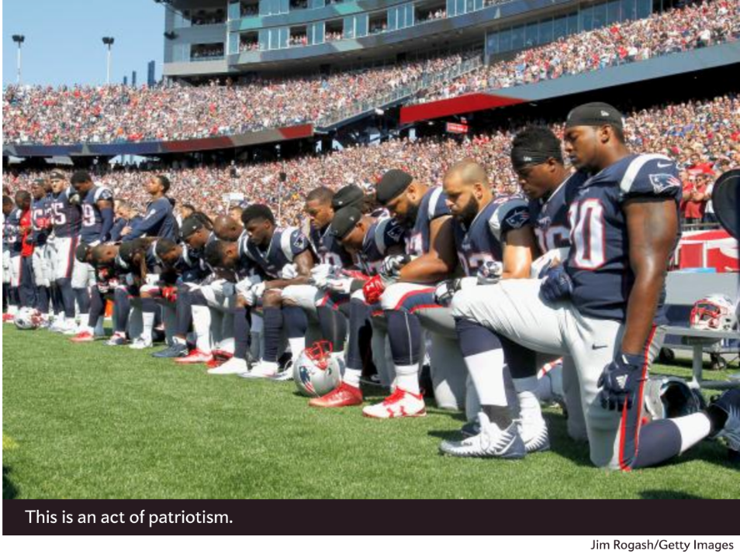
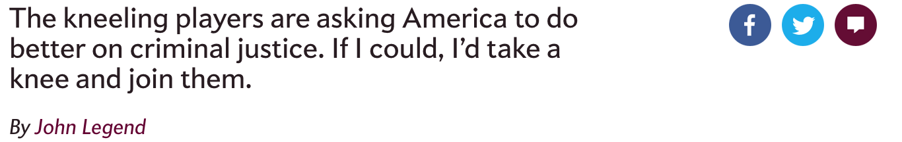
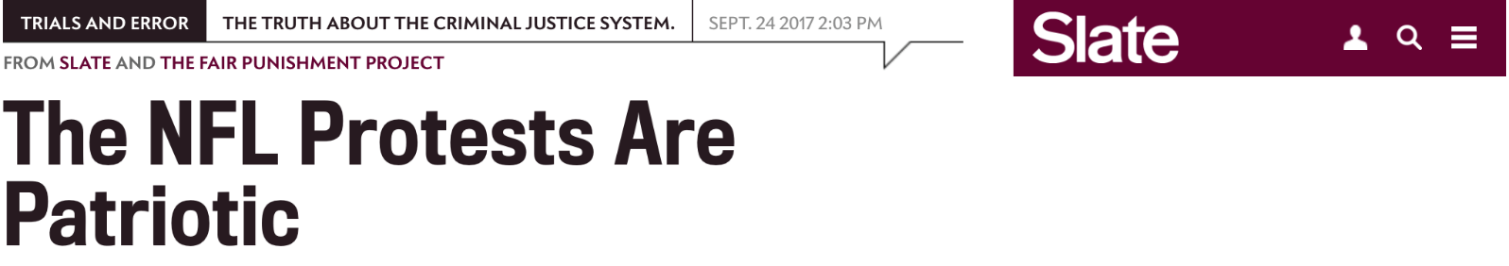
The president of the United States loves to drape himself in the symbols of patriotism, but fails to respect the ideals at the core of our Constitution and national identity. Trump may love the flag, but he doesn’t love anything it’s supposed to stand for. He actively encouraged a hostile foreign power to infiltrate our electoral process. He wants to suppress millions of Americans’ right to vote because they didn’t vote for him. He routinely undermines freedom of religion with his rabid Islamophobia, attacks the free press with disturbing regularity, and is now attacking the rights of the people to peacefully protest.
Protest is patriotic. Protest has played a critically important role in elevating the voices of the most vulnerable in our nation. Protest in America has been essential to ending war, to demanding equal rights, to ending unfair practices that keep citizens marginalized. If we quell protest in the name of patriotism, we are not patriots. We are tyrants.
Would there have been a Civil Rights Act without the Birmingham protests? When Bull Connor unleashed his fire hoses and dogs on the schoolchildren taking to the streets, racial disparities and the violence facing people because of the color of their skin became the issues of the times. With savage images of the brutal attack in the news every day, President John Kennedy had little choice but to push for a Civil Rights Act that demanded equal services and equal rights.
Protests in Selma, Alabama, changed the trajectory of this nation and catapulted the Voting Rights Act into being. Soon after images of Bloody Sunday flooded television sets, President Johnson presented to Congress the Voting Rights Act, which would remove barriers to voting like literacy tests. If you think these protests were irrelevant, consider Johnson’s words to Congress: “[A]t times history and fate meet at a single time in a single place to shape a turning point in man’s unending search for freedom ... So it was a century ago at Appomattox. So it was last week in Selma, Alabama.”
These are some of the most iconic protests in our history, but they are simply chapters in the great American novel where protests and social activism push us into a better and more just reality. There are the anti-war demonstrations of that decade, demanding that our soldiers be treated better in this country, that young men not be sent to their deaths for an unjust cause. The day before Woodrow Wilson’s election, thousands of suffragists marched down the street demanding the right to vote. Massive protests from steelworkers and coal miners propelled safer working conditions and better wages for millions of Americans. And where would we be, of course, without the Boston Tea Party?
These protests woke Americans up from complacency. And combined with other forms of social activism, they helped to show citizens, policymakers, and anyone listening that there could be a better way. That hope was not just an idea—a better future was both necessary and possible.
The protests are not some arbitrary statement about a flag.
The NFL protests carry on in this tradition. They are not some arbitrary statement about a flag. They are a demand that we Americans make this country’s reality match its proud symbolism. They are an attempt to educate the public that criminal justice—mass incarceration, lengthy sentences, police brutality—is the civil rights issue of our time. Colin Kaepernick, Michael Bennett, and Marshawn Lynch are demanding that this country again take a breath, self-reflect, and recognize that we fail a large and important population in this country by investing in prison systems rather than education and housing, by using the criminal system as a first rather than last resort, and by failing to punish police officers who engage in illegal racial profiling and police abuse. They are insisting that we do better.
To be clear, this is not the end of their activism. Malcolm Jenkins, who has raised a fist, and retired player Anquan Boldin are co-leading a “Players Coalition” of 40-plus players, working with grassroots activists and talking with legislators to demand police accountability and push for change in this country’s bail and juvenile sentencing scheme. Jenkins recently spent an afternoon watching bail hearings with the NFL Commissioner Roger Goodell, and Boldin left the league to devote all of his time to reform and humanitarian work. Colin Kaepernick has donated at least $900,000 to causes that work to better the lives of the most vulnerable. Chris Long is donating his first six game checks to fund scholarships to poor kids from his hometown of Charlottesville.
But even without this activism, the players’ protests are important. Because of them, almost every day of the week, we talk about racial disparities. People across this country are suddenly thinking about what it must feel like to be a person of color, watch an officer shoot an unarmed man, and walk away with a pension. And every time someone takes a knee or raises a fist, viewers must grapple with the why—with the uncomfortable reality that our country daily marginalizes thousands of people in impoverished communities.
I sing for a living—no one would want me on their NFL team. But if I could, I’d take a knee on Sundays. Because these conversations are necessary for progress. Because these protests are their own form of a pledge-of-allegiance—allegiance to the ideals that are our nation’s founding principles, which many heroes have given their lives to defend. They are the definition of patriotism.

